ATL Take-up Controller Design

Owen Lu

Electroimpact Inc.

owenl@electroimpact.com

*Abstract*— A servo system on the ATL head design is used to eliminate slack in the tape backing spool. Tension should always be maintained in the system during operation. Nominally, the take-up surface speed should match the tool-point surface speed during payout. This paper presents one possible method to develop a velocity controller that maintains a set tension in steady state.

# Introduction

It is assumed that controller development will take place after a system identification. Therefore, it is assumed that $J_{e},B_{e},u_{0}$ constants have all be experimentally determined. The plant model is shown in Figure 1.

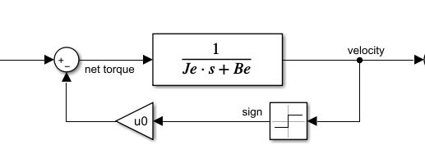

Figure 1 – Laplace domain model of the mechanical system

The central idea of the system is that the surface velocity of the backer is commanded to be higher than that of the tool point velocity in all cases. This assumes that the feed motor will have a controller tuned to reject the disturbance torque of the take-up creel and therefore maintain the material velocity near the commanded tool point speed. This means that the surface velocity at the backer will be have an approximate maximum equal to the feed motor surface velocity.

A controller is developed nominally to drive the velocity to commanded velocity. Since the commanded velocity is assumed to be greater than that of the tool point velocity, there will be residual error in steady state causing a torque increase due to integrating controller action. This control signal is then saturated using a calculated value that incorporates frictional effects and desired backer tension.

# Control Law

Neglecting the disturbance torque of the system, we develop the controller that drives the angular velocity $ω$ to $ω_{r}$ the reference velocity.

|  |  |  |
| --- | --- | --- |
|  | $$P=\frac{1}{J_{e}s+B_{e}}$$ | (1) |
|  | $$\frac{ω}{ω_{r}}=\frac{CP}{1+CP}$$ | (2) |

Suppose we assume the response form as a damped oscillator.

|  |  |  |
| --- | --- | --- |
|  | $$H=\frac{ω}{ω_{r}}=\frac{ω_{n}^{2}}{s^{2}+2ζω_{n}s+ω_{n}^{2}}$$ | (3) |

Then $C$ can be solved in terms of $J_{e},B_{e},ω_{n}^{2},ζ$ and takes the following form in Eq. 6.

|  |  |  |
| --- | --- | --- |
|  | $$H=\frac{CP}{1+CP}$$ | (4) |
|  | $$C=\frac{H}{P(1-H)}$$ | (5) |
|  | $$C=\frac{ω_{n}^{2}\left(J_{e}s+B_{e}\right)}{s\left(s+2ζω_{n}\right)}$$ | (6) |

Where:

$ω_{n}$ is the natural frequency

$ζ$ is the damping coefficient

$J_{e}$ is the reflected inertia of the backer load

$B_{e}$ is the viscous friction

Since it is assumed velocity is unidirectional, Coluomb frictional torque is then added in a simple feedforward to reduce error due to this disturbance. This assumption comes from the fact that $ζ>1$ can be chosen, resulting in a controller that does not create an overshoot in the velocity signal. The controller $C$ changes velocity error $e_{v}$ into torque commands $T_{m}$. Therefore, the governing differential equation in the time domain is given in Eq. 8.

|  |  |  |
| --- | --- | --- |
|  |  | () |
|  |  | () |

A second order differential equation in control torque $T_{m}$ must be solved over time and integrated to obtain $T_{m}(t)$. This can be done with Eulers method.

Initialize state variables:

|  |  |  |
| --- | --- | --- |
|  |  | () |
|  |  | () |

Update with Eq. 11

|  |  |  |
| --- | --- | --- |
|  |  | () |

Integrate for

|  |  |  |
| --- | --- | --- |
|  |  | () |
|  |  | () |

# Simplified Controller

In order to develop a second order response in the angular velocity a non-standard controller form is used. The advantage of this is that the velocity response is smoothed with zero derivative initially and torque gradually increases. Although this control response can be custom coded in most software, many systems incorporate PID blocks for ease of use. The more important aspect of these blocks is that sometimes they are also tied to high speed hardware that can calculate the PID much faster than if the code were to be run on an infinite loop within the main code execution. Furthermore, PID blocks also usually have the added benefit of having regular real time sampling intervals, simplifying calculations.

If instead of using Eq. 3, we instead use Eq. 14 controller equation $C$ becomes a standard PI controller shown in Eq. 15. A different way to express Eq. 15 is shown in Eq. 16 for convenience. Separating $K_{p}$ and $ω_{i}=\frac{B_{e}}{J_{e}}$ into another standard form.

|  |  |  |
| --- | --- | --- |
|  |  | () |
|  |  | () |
|  |  | (16) |

# Saturation and Coulomb compensation

The control law will indefinitely integrate error signal creating larger and larger torques if the reference velocity is not reached. This torque is then limited to be the viscous friction at feed motor velocity added to the desired torque due to tension. Note that this value does not include the Coulomb friction torque.

|  |  |  |
| --- | --- | --- |
|  |  | () |

Therefore, we use Eq. 15 If

|  |  |  |
| --- | --- | --- |
|  |  | () |

Afterward we add $u_{0}$ to $T_{m}$. Thus, the total control signal $C_{out}$ torque is written as the sum of saturated torque and $u_{0}$ in Eq. 19. Note that when calculating $T_{m}$ using the equation in Eq. 18, do not substitute with .

|  |  |  |
| --- | --- | --- |
|  |  | () |

# Simulation Verification

In order to show that the torque will grow to specified torque in steady state a simulation is run.

The simulation is initialized with the following constants:

$$ω_{r}=1rads^{-1}$$

$$ω_{sat}=0.5rads^{-1}$$

$$B_{e}=1$$

$$T_{T}=1.5Nm$$

$$T_{sat}=2Nm$$

Figure 2 shows that the initial response of the angular velocity follows a second order overdamped system as expected. However, after hitting the threshold of $0.5rads^{-1}$ which is assumed to be $ω_{f}$ the feed velocity, further growth is stopped. At this point, torque build up continues until the saturation is reached, and is clamped to $2Nm$.

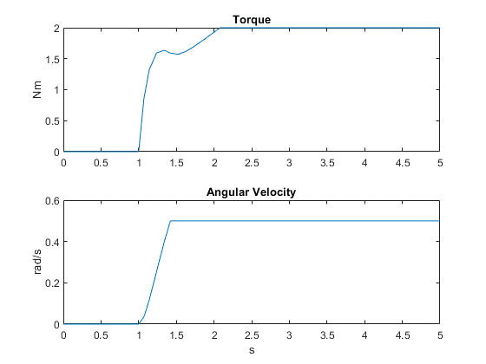

Figure 2 – Torque and velocity simulation